Class , sequence and architecture diagram

User : User has methods press () the elevator button and then when he gets in to the elevator he gives a voice command () to take to the floor and getdown() when reached the desired floor

Floor Button : It receives the input from the user and calls the elevator

Elevator : it receives the call from the floor button and send the message to the driver control

Driver control : It plays vital role in the elevator system. It moves the elevator to the called floor , then it create moves either up or down based on the floor button request and takes to the desired floor by user voice command.

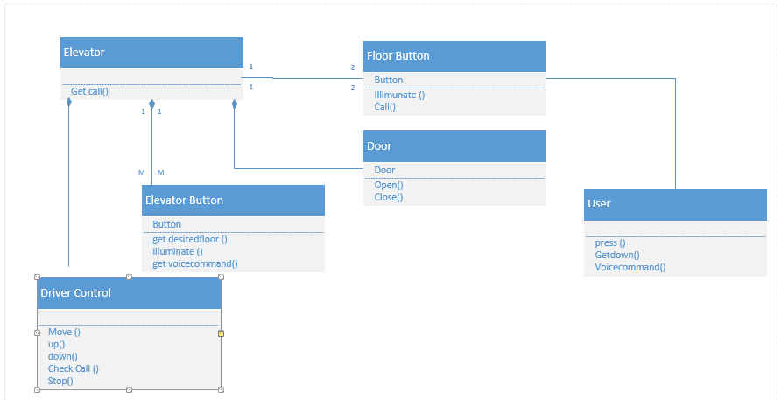Door: these are controlled by the driver control when elevator reaches the desired floor it generates the doors to open and close

(Innovation: Voice commands by the User )

Class Diagram

Sequence Diagram

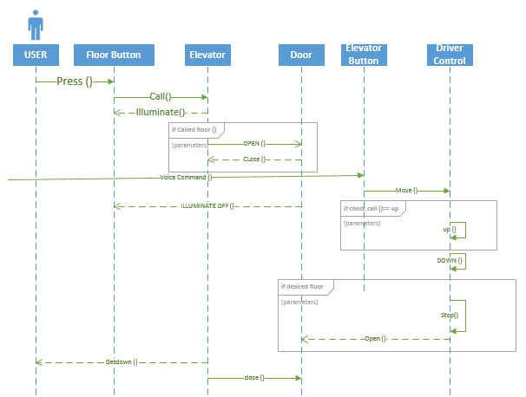

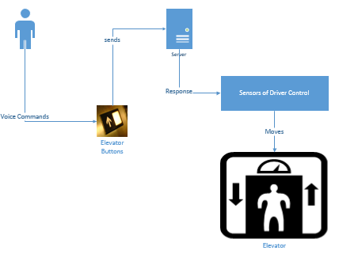

Architecture Diagram :